Scanning Documents Using the Copy Machines
Press the Services Home button on the copier (All copiers will scan)
Choose Network or Workflow Scanning. If it asks you, put in your copy code. Not all machines in the district will ask for your code.
Use the up and down arrows to find your name.
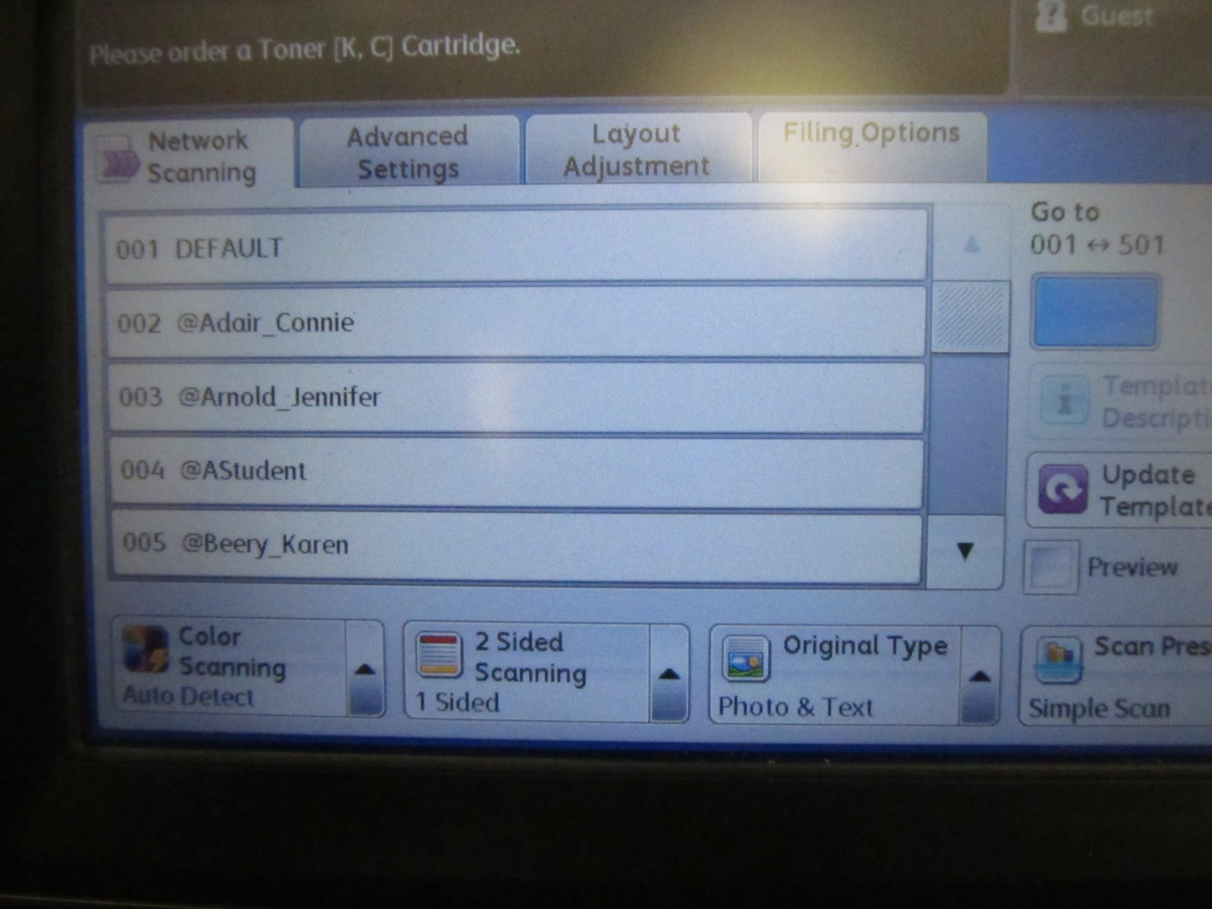
Choose your name by tapping it. Be sure that your name highlights before moving on.
Place item in the feeder as if you are going to copy it or lift lid and place on glass. The feeder works for normal size paper. You can put multiple items in the feeder at the same time, however they will all be scanned to one file and you will have to scroll through the file to see all of them. If you need to have your scanned items saved individually, you will have to put them in one item at a time.
Press Start – The item scans and saves as a pdf to your teacher folder inside a folder called “scanner”. Once it is there you can treat it as you would any file on your computer to send, attach etc.

Advanced Scanning:
If you choose to complete any of advance scanning steps below, do so before touching start.
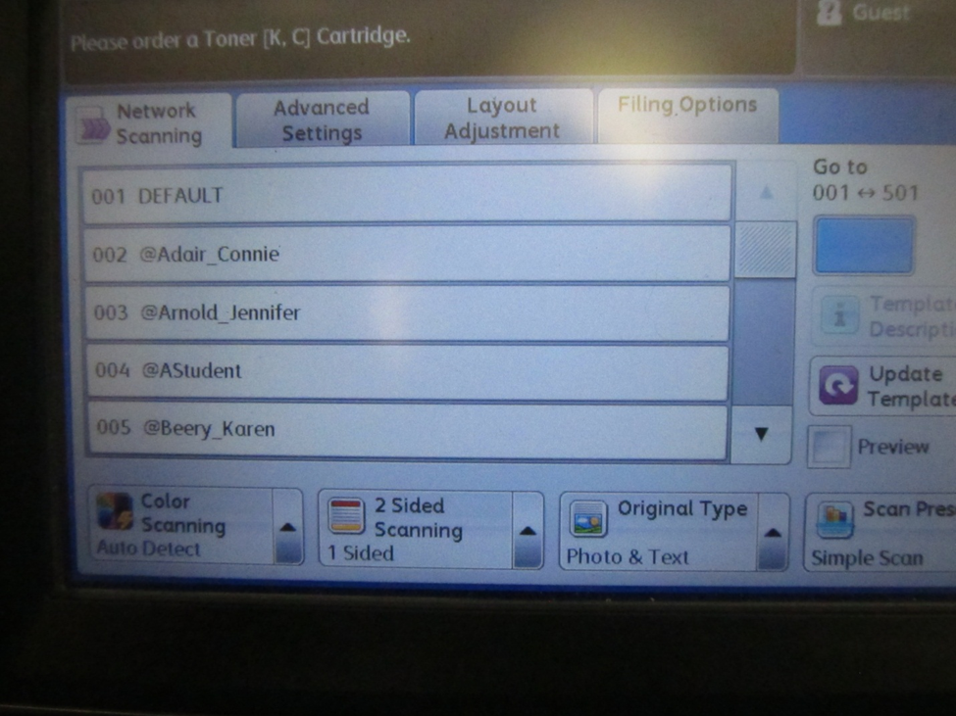
2 Sided scanning: If your document is duplexed, you can change the “2 Sided Scanning” to accommodate this then put your document in the feeder and it will automatically scan both sides. Just change this setting to “2 Sided” by clicking the arrow.
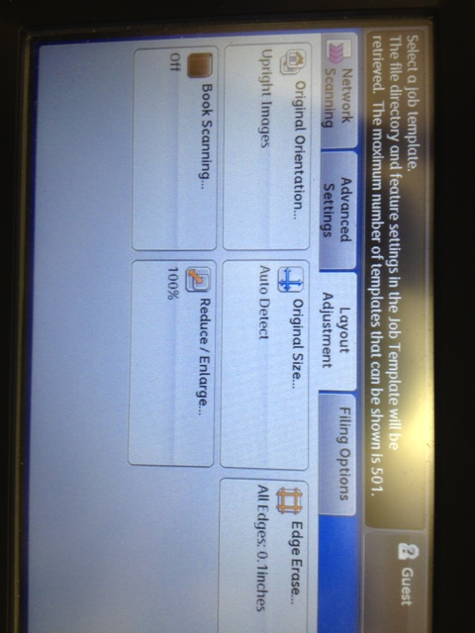

Book Scanning: If you choose the “Layout Adjustment” tab you can do Book Scanning. This will have the scanner scan both sides of the glass. Just click the tab and then turn “Book Scanning” on.
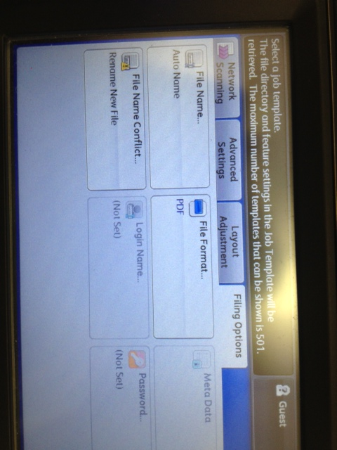
Filing Options: The document you scan gets a default name which is sometimes hard to understand. If you want to give your document a unique name click the “Filing Options” tab. Touch the “File Name” button and enter a name you would like for your document and then touch save.

