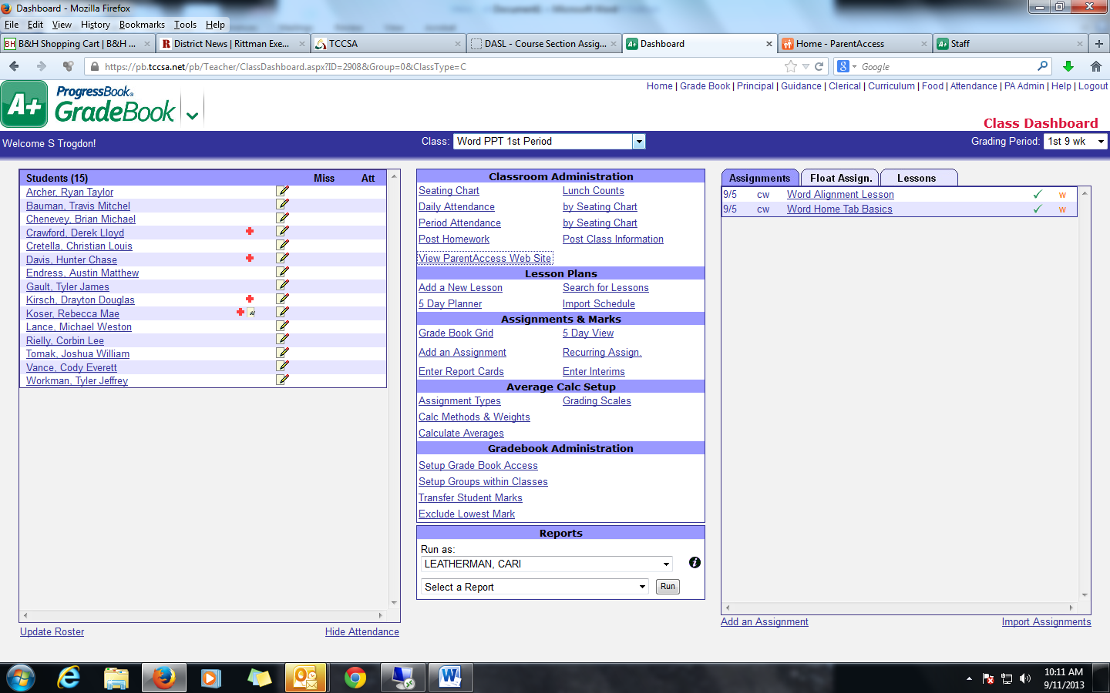

*From the Dashboard of the class that the student is in, click on: “View Parent Access Web Site”*

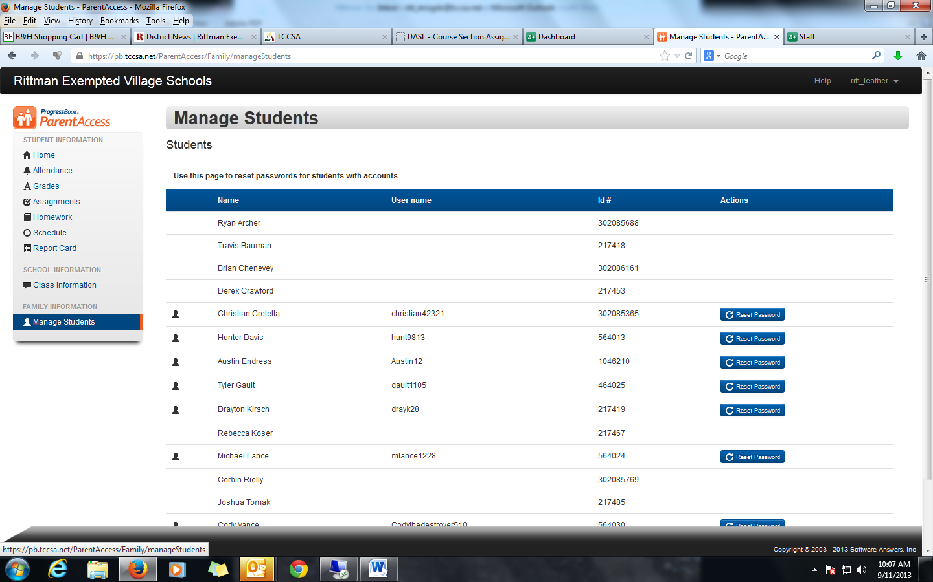

Choose “Reset Password”

They will have to tell you a password they want to use and you will have to type it twice. Passwords must be 8 Characters and have at least one number.

Choose “Manage Students”